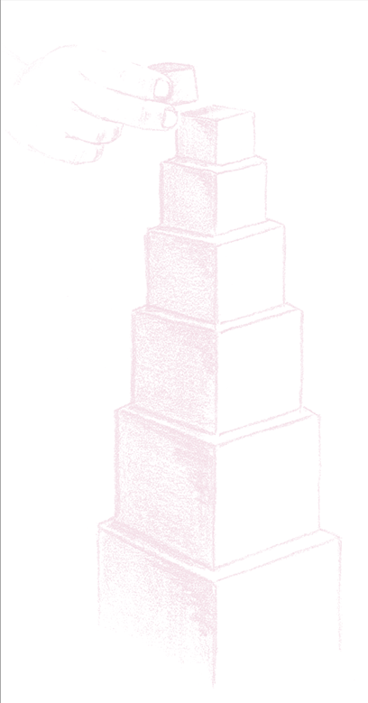
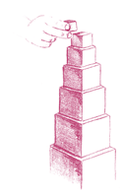
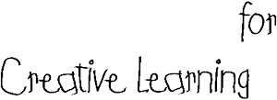
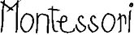
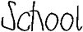
1627 Brodhead Road ■ Moon Township, PA 15108
www.montessoriscl.com
724.457.KIDS

2022-2023 Student Application
Last Name First Name Birthday Sex
M F

Address

Mother/Father Name

Address

Phone Number
Home: Cell: E-Mail
Employer Name Occupation

Employer Address and phone number

Mother/Father Name

Address

Phone Number
Home: Cell: E-Mail:
Employer Name Occupation

Employer Address and phone number

Other members of the family

List 6 Adjectives to describe your child

Mother/Father:

Mother/Father:

How did you hear about our school?

What do you expect from a Montessori Education?

Mother/Father:

Mother/Father:

Family Information
Parents separated or divorced?
Either parent away for long periods?
Child cared for by any other person?
Was your child full term?
Is child adopted?
Does your child have any special needs / allergies?
Do you take your child on outings? If yes, how often?

*Ethnic Origin White Black Hispanic Asian American Indian

*Please note that this is required by the state

The above information is true and accurate and will remain confidential.

PARENT (S) SIGNATURE_____________________________________DATE____________

A $50.00 Non Refundable application fee must accompany this form. Please make checks payable to Montessori School for Creative Learning.

For office use only Check#___________ Amount____________ Date____________

